Year 4 Homework, Spring Term 2 Week 3

**Maths: Fun Five!**

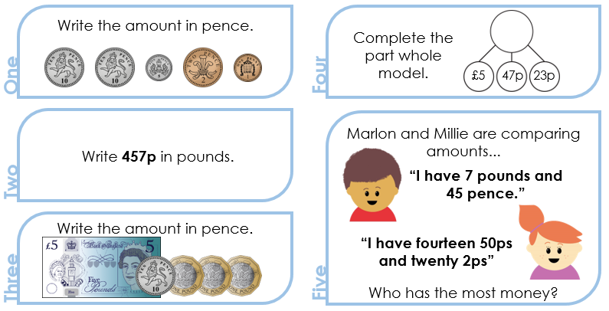

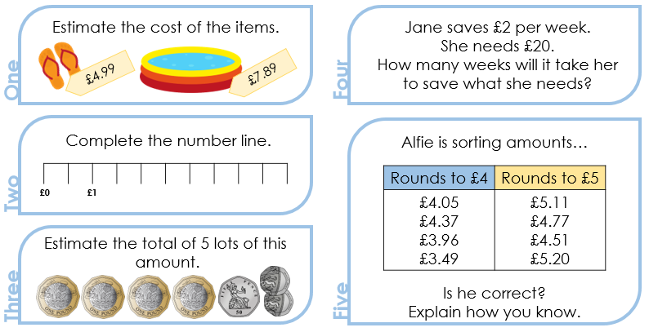

**Quick Comprehension:** Complete the reading comprehension. Children should allow themselves one minute to read the text, and five/ten minutes to answer the questions. Some of the questions are quite tricky, so don’t worry if you have to talk them through with an adult.

**Spellings**

|  |  |
| --- | --- |
| **Core**  serious  obvious  glorious  curious  previous  calves  elves  thieves  leaves  wolves  after  never  under  river  February  library | **Support**  sinkable  readable  drinkable  enjoyable  reader  banker  teacher  driver  farmer  food  tooth  school  little  like  famous  various |

|  |
| --- |
|  |

**SPaG Challenge in books please**



**Times Tables Activities**

**Please do some of the following:**

Daily times tables on TT Rockstars

Daily time tables in booklet

Times tables training grid

Times tables wheels

Daily chanting and oral questioning

Please remember: All homework is marked in class with the children and will not have written feedback on it.

Homework is due in on the following Friday.

